2018-2019 and 2019-2020
Call for Projects
TRANSPAC Measure J Line 20a Funds
Additional Transportation Services for Seniors and People with Disabilities

- TRANSPAC, the Regional Transportation Planning Committee for Central Contra Costa is issuing a Call for Projects for Measure J Line 20a funds "Additional Transportation Services for Seniors & People with Disabilities" funded through the Measure J Transportation Sales Tax Expenditure Plan approved by Contra Costa voters (in 2004) for the two year period of FY 2018-2019 and 2019-2020.

- Funds will generally be used in support of transportation services and related capital expenditures for seniors and people with disabilities provided by TRANSPAC jurisdictions and public and private non-profit agencies operating in the TRANSPAC area (map attached). Funds must be spent in a manner consistent with the Contra Costa Transportation Authority’s Measure J Program 15 Transportation for Seniors & People With Disabilities. Examples of eligible expenditures include but are not necessarily limited to: vehicle purchase/lease/maintenance, mobility management activities, travel training, facilitation of countywide travel and integration with other public transit.

- According to Measure J, in years when revenues have declined from the previous year, funds may be used for supplemental, existing, additional or modified service for seniors and people with disabilities; in years where funding allows for growth in service levels, these funds would be used for service enhancements for seniors and people with disabilities and if funding levels are restored to 2008 levels, these funds shall be used to enhance services for seniors and people with disabilities. TRANSPAC will determine if the use of funds proposed by operators meets these guidelines for the allocation of these funds.

- Eligible Applicants: TRANSPAC jurisdictions, public non-profit and private non-profit transportation service agencies, duly designated by the State of California and operating in TRANSPAC area in Central Contra Costa may submit application(s) for operating funds for transportation services and/or capital funding projects necessary to continue and/or support existing services for twenty-four (24) months. Transportation services and projects must directly benefit seniors and disabled residents of Central Contra Costa (Clayton, Concord, Martinez, Pleasant Hill, Walnut Creek, and Unincorporated Central Contra Costa County). Please see attached map.

- Funding Available: The total funding available for this two-year grant/project period is estimated to be $880,000 ($440,000 annually).
- Evaluation Criteria: Applications will be evaluated on the following criteria which should be addressed in the grant application:
- Proposed service fills an identified gap in transportation/transit network.
- Proposed service complements the transportation services provided by the County Connection LINK Americans with Disabilities Act paratransit service.
- Does the proposal include any service coordination efforts with other accessible or fixed route transit operations, use of mobility management services, etc.
- The costs of operations relative to the cost of the LINK Paratransit service
  - $70.88 per revenue hour (2015/2016)
  - $35.19 per passenger (2015/2016)
- Is the service currently being funded by the 20a program
- Demonstration of the capacity, commitment and funding strategy to continue service beyond the grant period.
- Though matching funds are not required, providing matching funding and leveraging other fund sources will be viewed favorably.
- Equity analysis of the transportation services provided in the TRANSPAC Subregion

- Applications: Applicants are required to complete the attached application form and may attach additional information in support of the application. The TRANSPAC Board will request application review and a program recommendation from TRANSPAC TAC. The TRANSPAC Board will make funding recommendations to CCTA and request allocation action(s).
- Applications should be mailed, hand delivered, or emailed (preferred, pdf format), to:
Matt Todd, Managing Director
1676 No. California Blvd., Suite 400
Walnut Creek, CA 94596
matt@graybowenscott.com
- Applications must be received by 3:00 pm on Monday, February 5, 2018.
- An electronic copy of the application is available by email. Please contact Matt Todd, Managing Director, at matt@graybowenscott.com for the electronic version.
- Faxed applications and late applications will not be accepted.

- Contra Costa Transportation Authority Allocation Process: Successful applicants will be required to execute a Cooperative Funding Agreement with the CCTA and comply with all of its requirements, including, but not limited to, audits, compliance with the Measure J Expenditure Plan as it pertains to the project, insurance (see attachment Sample Contra Costa Transportation Authority Grant Insurance Requirements on page 15 of the Call for Projects package) , indemnification, and reporting. A sample Cooperative Agreement is attached to this application. Pursuant to CCTA policies and procedures established in the Cooperative Funding Agreement referenced above, project sponsors will be reimbursed for eligible, documented expenses pursuant to the approved program/project budget and scope, schedule and/or project description.
9. Reports to TRANSPAC and the Contra Costa Transportation Authority: First and second year grantees will be required to report on a quarterly basis to TRANSPAC and/or the Contra Costa Transportation Authority on the transportation services and related capital projects funded through this Call for Projects. For grantees with two years of 20a grant funding history, the reporting requirement is annual contingent upon no identified issues in prior reports.

TRANSPAC
APPLICATION
Call for Projects
TRANSPAC Measure J Line 20a Funds
Additional Transportation Services for
Seniors and People with Disabilities
Transportation Partnership and Cooperation
Applications must be received by
3:00 pm on Monday, February 5, 2018.
Applications may be emailed to
Matt Todd, Managing Director at:
matt@graybowenscott.com

-Additional information may be included as attachments
-Please provide clear and concise responses that address the application question
-Fiscal Year (FY) is defined as July 1 to June 30

APPLICATION INFORMATION
Contact Information
Name of Agency
Primary Contact Name
Street Address
City, State, Zip
Phone
Email Address
I certify that the information contained in this application is true and complete to the best of my knowledge.
Signature of Responsible Party Date

Please provide clear and concise responses that address the application question

- Overall Program
(Provide an overview of your agency, mission, and overall services provided)

- Transportation Program/Project/Service Name
(specific component of the funding request)
  - Service area boundaries

  - Days and hours of operation
(include frequency if applicable)

- Is this a request for continuing or expanding existing service funded by Line 20a funding?
If the answer is “yes”, please provide:
- The date of first expenses reimbursed by Measure J, and
- The date of the last progress report submitted and the period reported on (and attach the progress report)

- Please review the minimum insurance requirements required to enter into a grant agreement with the Contra Costa Transportation Authority (page 15 of the call for projects package). Is the agency able to meet the minimum insurance requirements of the granting agency?

OPERATIONAL INFORMATION
(information regarding service requesting funding for)
- Type of service

- Purpose and need of service

- Description of service to be provided

- Describe:
  - The benefit of the proposed services to the public and / or the public transportation system;

  - How the proposed service fills an identified gap in transportation/transit network; and / or

  - How the service complements the County Connection LINK Americans with Disabilities Act paratransit service.

- Describe any efforts to coordinate services or other resources with other transportation providers or mobility management organizations.

- Provide information regarding fleet description, driver training, and other support provisions for the service (i.e. maintenance, dispatch)

- Description of trip origins (by community) and types of destinations (within the TRANSPAC RTPC, that cross RTPC boundaries, or cross transit service areas)

- Describe the agency approach and strategy to continue the operation of the service beyond the Line 20a funding grant period.

Please provide the information requested in Table 1 below
TABLE 1 (Page 1 of 2)
 |  | Last 12 Month Period |  | Projected for
 |  | (Assume Calendar Year 2017; or |  | FY 2018/2019
 |  | specify other time period below) |  | (7/1 to 6/30)
 |  | ______________________
 |  | Monthly Avg | Annual | Monthly Avg | Annual
Number of individuals served by the transportation program
 | Total number of individuals
 | Number of individuals in Central Contra Costa
Trips provided (one way trips)
 | Number of total trips provided
 | Number of trips provided in Central County
 | Number of shared trips
 | Number of trips that could have been ADA trips
Vehicle Hours of service provided
 | Number of total hours provided
 | Number of hours provided in Central County
Provide a description of how a vehicle hour is defined
(i.e. leave garage / return to garage, first pick up / last drop off, if includes wait times)

TABLE 1 (Page 2 of 2)
 |  | Last 12 Month Period |  | Projected for
 |  | (Assume Calendar Year 2017; or |  | FY 2018/2019
 |  | specify other time period below) |  | (7/1 to 6/30)
 |  | ______________________
 |  | Monthly Avg | Annual | Monthly Avg | Annual
Cost
 | Per hour of service
 | Per passenger trip
Assumptions
-Provide detail of assumptions used for projected information
-If projected service has a substantial variance from past operations, please provide an explanation for the variance
-Provide additional information if FY 2019/20 is projected to vary significantly from the information above

Program Schedule
- Include expected initiation of service and duration of services to be provided
  - Please note this is different information requested from the service days and hours of operation
- Include milestones needed to be achieved to initiate new programs (applications for new services are anticipated to require more detail in this section of the application, with detail about milestones needed to prepare and implement the new service)
- Add lines as needed
TABLE 2
Milestone Date
(month/year)

Funding Sources for the Proposed Program
- Add lines as needed
TABLE 3
Funding Source | ($) |  |  | Percent of  Funding
 | FY 18/19 | FY 19/20 | TOTAL
Line 20a funds
Fare Revenue (if applicable)
TOTAL

Expenditure budget for the Proposed Program
- Detail the total expenses for the project period by budget line item detail and the amount of Line 20a funds that will be used for the budget line item
- The Total of the Budget Line Items should match the Total Funding Sources detailed above
- The Total Line 20a funds should match the grant request amount
- Add lines as needed.
TABLE 4
Budget Line Item  Description | ($) |  |  | Amount of Line 20a  Funds
 | FY 18/19 | FY 19/20 | TOTAL
TOTAL

Total Program Budget (i.e. of the Overall Agency)
Percentage of Budget Transportation Program Represents
Provide additional information if the projected expenditure of the line 20a funds over FY 2018/19 and FY 2019/20 are not proposed to be balanced over the two year period.

Capital Projects: Description of related capital project(s) for which funding is sought
(Capital project funding requests will be considered as stand alone requests. Capitol project funding requests require the General and Operational project information to be completed)
- Purpose /Goal of Capital Project

- Project Description: type, location, service life

- Describe the benefits of the proposed capital project to the general public and/or the public transportation system

Schedule of Capital Procurement milestones
- Include milestones needed to be achieved in advance of purchase
- Include milestone when equipment would begin service
- Add lines as needed
Milestone Date (month/year)

Funding Sources for the Capital Project
- Add lines as needed
TABLE 5
Funding Source | ($) |  |  | Percent of  Funding
 | FY 18/19 | FY 19/20 | TOTAL
Line 20a funds
TOTAL

Expenditure budget for Capital Project
- Detail the total expenses for the Capital Project by budget line item detail and the amount of Line 20a funds that will be used for the budget line item
- The Total of the Budget Line Items should match the Total Funding Sources detailed above
- The Total Line 20a funds should match the grant request amount
- Add lines as needed.
TABLE 6
Budget Line Item  Description | ($) |  |  | Amount of Line 20a  Funds
 | FY 18/19 | FY 19/20 | TOTAL
TOTAL

MAP OF SERVICE AREA
Describe AND attach a map of your service area. Services must be provided in Central Contra Costa (Clayton, Concord, Martinez, Pleasant Hill, Walnut Creek, Unincorporated Central Contra Costa County)

TRANSPAC Area Map
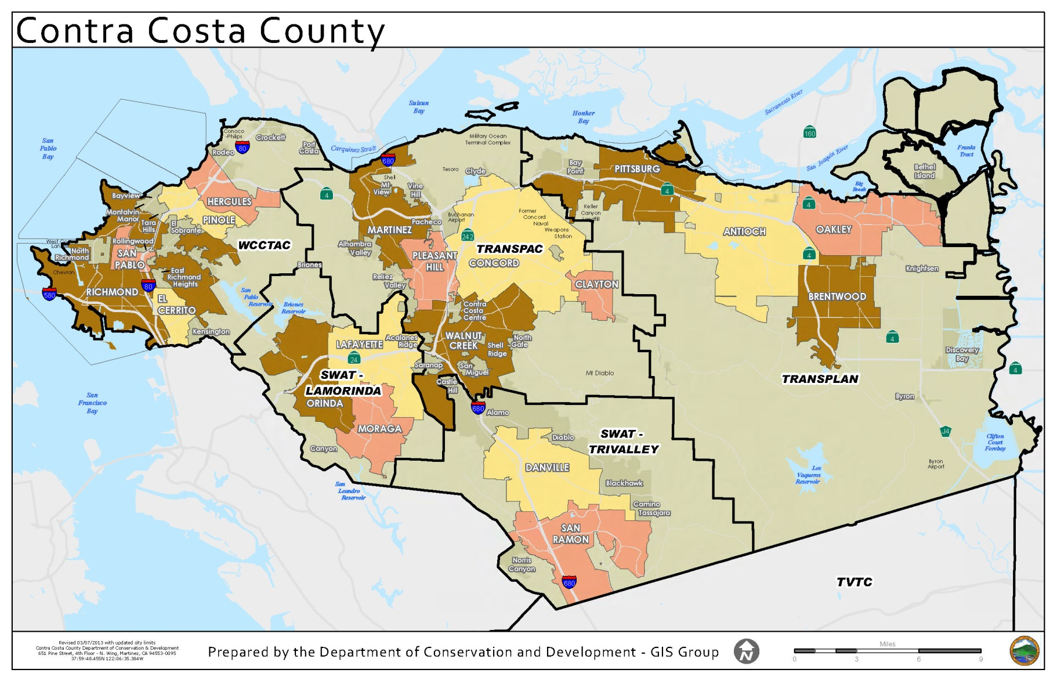
SAMPLE CONTRA COSTA TRANSPORTATION AUTHORITY Page 1 of 3
GRANT INSURANCE REQUIREMENTS (2016)
SPONSOR shall maintain the following insurance in force during the entire term of this AGREEMENT, and in the case of Commercial General Liability Insurance and Professional Liability Insurance for at least five years after the conclusion of all services provided by SPONSOR pursuant to this AGREEMENT. SPONSOR's contractors and consultants shall be subject to the same insurance provisions as stated herein unless specified otherwise:

    - Workers' Compensation Insurance covering SPONSOR's employees in accordance with statutory requirements of all jurisdiction(s) in which any and all Services are being performed, and Employer's Liability Insurance in the amount of$1,000,000 per occurrence for injuries incurred in providing services under this AGREEMENT. This policy shall include a waiver of subrogation stating that the insurer waives all rights of subrogation against the AUTHORITY, its officials, employees, or successors in interest.

    - Comprehensive or Commercial General Liability Insurance including contractual liability, premises and operations, personal injury, completed operations, and independent contractors liability, with limits of not less than $1,000,000 each occurrence for bodily injury and not less than $1,000,000 each occurrence for property damage. (Aggregate is $3,000,000 bodily injury and property damage)

A combined single limit policy is acceptable provided the combined single limit is not less than $1,000,000. The policy shall contain an aggregate limit not less than $3,000,000. The required limits may be satisfied by a combination of a primary policy and an excess or umbrella policy with terms at least as broad as the primary policy.

The policy shall contain no endorsements or provisions limiting coverage for products and completed operations; (2) contractual liability; (3) third party action over claims; or (4) cross liability exclusion for claims or suits by one insured against another.

    - Automobile Liability Insurance covering owned, non-owned, uninsured motorists, leased and hired vehicles with limits not less than $1,000,000 each person and $1,000,000 each occurrence for bodily injury, and $1,000,000 each occurrence for property damage. A combined single limit of not less than $1,000,000 will meet this requirement. AUTHORITY shall be added by SPONSOR as an additional insured on this policy. SPONSOR'S insurance policy shall be primary insurance with respect to

SAMPLE CONTRA COSTA TRANSPORTATION AUTHORITY Page 2 of 3
GRANT INSURANCE REQUIREMENTS (2016)
the AUTHORITY and its employees, agents, officers and directors and any insurance maintained by AUTHORITY shall be excess of SPONSOR'S insurance.

    - Professional Liability Insurance (covering errors and omissions), with limits not less than $1,000,000 Social Services Professional per claim and a deductible not to exceed $2,000,000 Aggregate, and a retroactive date no later than the beginning date of this AGREEMENT as shown on Page 1 of this AGREEMENT.

SPONSOR's subcontractors and subconsultants providing professional services under this AGREEMENT shall be added to SPONSOR's policy as additional insureds, or shall provide evidence of their own professional liability insurance which is acceptable to AUTHORITY's Executive Director.

The policy or policies of insurance required by Section 10.b Comprehensive or General Commercial General Liability Insurance and 10.c Automobile Liability Insurance shall conform to or include the following:

- A provision or endorsement naming AUTHORITY, its officials, employees, and successors in interest as additional insureds with respect to the liability arising out of the performance of any obligations by SPONSOR under this AGREEMENT, including completed operations coverage.

- Provisions that the insurance is primary insurance with respect to AUTHORITY, its officials, employees, and successors in interest. Any insurance or self-insurance maintained by AUTHORITY, its officials, employees, or successors in interest shall be excess of SPONSOR’s insurance and shall not contribute with it.

- Provisions or endorsements stating that the coverage contains no special limitations on the scope of protection afforded to AUTHORITY, its officials, employees, or successors in interest.

- Provisions or endorsements stating that insurance shall apply separately to each insured against whom claim is made or suit is brought, subject to the limits of the insurer's liability.

- Provisions or endorsements providing a waiver of subrogation in favor of AUTHORITY, its officials, employees, or successors in interest or shall specifically

SAMPLE CONTRA COSTA TRANSPORTATION AUTHORITY Page 3 of 3
GRANT INSURANCE REQUIREMENTS (2016)

allow SPONSOR to waive their right of recovery prior to a loss. SPONSOR hereby waives its own right of recovery against AUTHORITY.

All policies shall be issued by insurance companies which are licensed carriers in the State of California and maintain a Secure Best's rating of “A-" or higher unless otherwise approved by AUTHORITY.

Concurrently with the execution of this AGREEMENT, SPONSOR shall furnish to AUTHORITY a copy of each policy of insurance required by this AGREE1\1ENT. Such policies shall provide that not less than thirty (30) calendar days advance notice in writing will be given to AUTHORITY prior to cancellation, termination, or material alteration of said policies of insurance, except 10 calendar days in the event of non-payment of premium.

The requirements contained herein as to types and limits of insurance to be maintained by SPONSOR are not intended to and shall not in any manner limit or qualify the liabilities and obligations assumed by SPONSOR under this AGREEMENT.

TRANSPAC 20A Program Grant Progress Report Page 1 of 3

This reporting template is for information only in this grant application. If you receive a grant you will be required to file this progress report per the grant requirements.

Name of Agency:
Primary Contact Name:
Street Address, City, State, Zip:
Phone:
Email:
Project Funded:
Date of Grant:
Amount of Grant:
Progress Report Period:

I certify that the information contained in this report is true and complete to the best of my knowledge.
Signature of Responsible Party
Date

TRANSPAC 20A Program Grant Progress Report Page 2 of 3
Reporting Data and Backup Documentation
- Summary of activities/services/impact made possible by grant funds

- Number of persons served
- Total transportation program
- Number of persons in Central Contra Costa
3. Number of trips provided (one way trips) (monthly/annually)
- Number of total trips provided
- Number of trips provided in Central County
- Number of shared trips

- Vehicle Hours of service provided
- Number of total hours provided
- Number of hours provided in Central County
- Description of how a service hour is defined

- Expenses
  - Cost of Transportation Program in reporting period
  - Line 20a funds utilized in reporting period

- Cost per vehicle hour of service

- Cost per trip

- Review any variance of persons served, trips provided, and hours of service provided from application assumptions

- Trip Characteristics:
a. Describe the provision of any the services that are above and beyond ADA requirements?
b. Are trips eligible for ADA paratransit? Provide documentation
c. Common Destinations within the RTPC
d. Day/Time trip breakdown: Mon-Friday? AM? PM? Weekends?
e. Trip Geography:
- Identify trip destinations that cross the RTPC boundaries.
- Identify trip destinations that cross transit service areas?
TRANSPAC 20A Program Grant Progress Report Page 3 of 3
Reporting Data and Backup Documentation (continued)
10. Program Characteristics:
a. Current capacity
b. Waitlist status and/or other program needs, barriers, etc.
c. Fleet description and status
d. Driver training description
11. First and Second Year Grantees, please attach drivers log or other substantiation of trips/routes. Subsequent year grantees must retain records for 3 years.
12. Attach documentation of capital purchases (if funded with Line 20a funds).
13. Describe any coordination activities with other transportation providers or mobility management function.

Full program description is available in the Measure J Sales Tax Expenditure Plan: http://www.ccta.net/uploads/5297b121d5964.pdf
First and second year nongovernmental grantees must have their Board of Directors authorize or approve the grant application by February 15th. Authority for subsequent grant applications and reporting may be delegated to the agency executive officer.
To be filed as follows: First and Second Year Grantees must file quarterly. Subsequent year grantees to file annually contingent upon prior reports having no identified issues.

