TRANSPAC
APPLICATION
Call for Projects
TRANSPAC Measure J Line 20a Funds
Additional Transportation Services for
Seniors and People with Disabilities
Transportation Partnership and Cooperation
Applications must be received by
3:00 pm on Friday, January 19, 2024.
Applications may be emailed to
Tiffany Gephart, TRANSPAC Clerk at:
tiffany@graybowenscott.com

-Additional information may be included as attachments
-Please provide clear and concise responses that address the application question
-Fiscal Year (FY) is defined as July 1 to June 30

APPLICATION INFORMATION
Contact Information
Project Title
Name of Agency
Primary Contact Name
Street Address
City, State, Zip
Phone
Email Address
I certify that the information contained in this application is true and complete to the best of my knowledge.
Signature of Responsible Party Date

Project Title _________________________

Please provide clear and concise responses that address the application question.
If your organization provides more than one transportation program, please provide responses for each program component as needed.

- Overall Program
(Provide an overview of your agency, mission, overall services provided, and section of the IRS code your non-profit operates under)

- Transportation Program/Project/Service
  - Name of the Program, Project, or Service
(specific component of the funding request)

  - Eligibility requirements to use Program, Project, or Service

  - Include program boundaries such as trip caps, dollar caps, max subsidy, etc.
  - Service area boundaries and common trip origins and/or destinations

  - Days and hours of operation
(include frequency if applicable)

- Is this a request for continuing or expanding existing service funded by Line 20a funding?
If the answer is “yes”, please provide:
- The date of first expenses reimbursed by Measure J, and
- The date of the last progress report submitted and the period reported on (and attach the progress report)

- Please review the minimum insurance requirements required to enter into a grant agreement with the Contra Costa Transportation Authority (see section 1.9 of the Sample Master Agreement) Is the agency able to meet the minimum insurance requirements of the granting agency?

OPERATIONAL INFORMATION
(information regarding service requesting funding for)
- Type of service.

- Purpose and need of service.

- Provide a brief description (125 words or less) of the service to be provided. Please note: this section is required even if your program is described elsewhere in the application. This description will be used for other program documentation purposes (i.e. in project funding agreement).

- Describe:
  - Eligibility requirements as well as who uses the program and relevant policies and guidelines for the service;
  - The benefit of the proposed services to the public;
  - How the proposed service fills an identified gap in transportation/transit network; and/or how the service complements the County Connection LINK Americans with Disabilities Act paratransit service.
  - Do the users of the program also use the LINK service (i.e. eligible and use the service, are eligible but do not use the service, are not eligible for the LINK service)?
  - Describe the provision of any components of the Line 20a Grant funded service that would be above and beyond a trip provided by the LINK service?
  - Please indicate which descriptions apply to the service provided (can select more than one)
___ On Demand Curb to Curb Service
___ On Demand Door to Door Service
___ On Demand Door through Door Service
___ Service focused on a common destination or program – Curb to Curb
___ Service focused on a common destination or program – Door to Door
___ Service focused on a common destination or program – Door through Door
___ Fixed-Route Service
___ Volunteer Driver Service
___ Regularly Prescheduled Trips to a Program
___ Service Provided by a TNC___ Taxi____
Please include any additional information or suggest different description as required:

  - Please indicate which cities your transportation program serves.
___ Clayton
___ Concord
___ Martinez
___ Pleasant Hill
___ Walnut Creek
___ Unincorporated Contra Costa County

- Describe any efforts to coordinate services or other resources with other transportation providers or mobility management organizations (including software programs) or why you do not share resources with other agencies.

- How does your program help implement the development of the goals of the Accessible Transportation Strategic Plan Task Force?

- Provide information regarding fleet description, driver training, and other support provisions for the service (i.e., maintenance, dispatch).

- Provide a breakdown of expected trip origins and destinations (by community) and types of destinations. Include information about trips and if they are within the TRANSPAC area or involve areas outside of the TRANSPAC area (or other transit service areas). Trip origin/destination information by city/zip code is also requested. Include the basis of the assumption (i.e., based on past period of service or other).

- Equity
Is the proposed program or project an origin-destination transportation service? If no (i.e. travel training, capital improvement project, etc), skip to question 13.e.
  - What percentage of individuals served are completely dependent on the proposed transportation program or service?
  - If the transportation program or service was not available, how would the users be impacted by the loss of service. Or if this service does not currently exist how are people making these trips now.
  - If the proposed transportation program or service is new, how are target users completing trips currently?
  - Percentage of users that can’t afford to pay for the service.
  - Provide information about trips provided that serve areas identified as Equity Priority Communities by MTC (see Equity Priority Maps on pages 17-19).

- Provide information about the capacity of the service and if there are any constraints to providing service (i.e., such as waitlists).

- Describe impacts COVID-19 and the resulting guidance and limitations on group gatherings and public distancing has had on the existing service as well as how it is expected to impact you program in the future, and how it will be accounted for in the proposed funding period.

- Describe the agency approach and strategy to continue the operation of the service beyond the Line 20a funding grant period.

Please provide the information requested below. If your organization provides more than one transportation program, provide the information in tables for each program component.

 |  | Last 12 Month Period |  | Projected for
 |  | (Assume Calendar Year 2023; or |  | FY 2024/2025
 |  | specify other time period below) |  | (7/1 to 6/30)
 |  | Monthly Avg | Annual | Monthly Avg | Annual
Number of individuals served by the transportation program
Number of unique individuals served over the period |  | N/A |  | N/A
Number of unique individuals in TRANSPAC area of Contra Costa County |  | N/A |  | N/A
* Please only include unique individuals served by the funded project/program.
** For example, if your program provided 10 people a total of 100 trips over the reporting period, the program has 10 unique individuals served over the period. If 2 of the people reside in Lafayette, 4 in Walnut Creek, and 4 in Concord, then there are 8 unique individuals in the TRANSPAC area.
*** TRANSPAC area of Contra Costa County includes Clayton, Concord, Martinez, Pleasant Hill, Walnut Creek, and the unincorporated areas within Central County (see map at https://transpac.us/).

 |  | Last 12 Month Period |  | Projected for
 |  | (Assume Calendar Year 2023; or |  | FY 2024/2025
 |  | specify other time period below) |  | (7/1 to 6/30)
 |  | Monthly Avg | Annual | Monthly Avg | Annual
Trips provided (one-way trips)
 | Number of total one-way passenger trips provided by the program
 | Number of one-way passenger trips provided by the program entirely in Central County (i.e. origin and destination within Central County)
 | Number of one-way passenger trips provided by the program with either the origin or destination in Central County
 | Number of one-way passenger trips provided by the program with neither the origin or destination in Central County
 | Number of vehicle trips provided by the program that included more than one passenger being transported
* For example, if your program has provided 10 people a total of 40 round trips and 20 one way trips, a total of 100 one way trips should be reported for the reporting period.
** One way trips provided entirely within TRANSPAC area of Contra Costa County (see map at https://transpac.us/) regardless of the residence of the individual can be included in the second row of the table.
*** Number of vehicle trips information example – Passenger A is picked up at a location 1, Passenger B is picked up at location 2, Passenger A and B are dropped of at location 3. This is an example of a share vehicle trip.

 |  | Last 12 Month Period |  | Projected for
 |  | (Assume Calendar Year 2023; or |  | FY 2024/2025
 |  | specify other time period below) |  | (7/1 to 6/30)
 |  | Monthly Avg | Annual | Monthly Avg | Annual
Vehicle Hours of service provided
Number of total vehicle hours of service provided
Number of vehicle hours of service provided in TRANSPAC area of Contra Costa County
See map at https://transpac.us/ for TRANSPAC area of Contra Costa County.

- Please describe how a vehicle service hour is defined
(i.e. leave garage / return to garage, first pick up / last drop off, if includes wait times)

Expenses
  - Cost of Line 20a Grant funded transportation program in (include direct costs of the service including (but not limited to) maintenance, administrative, and dispatching):
- Last 12 Month Period: Calendar Year 2023
- Projection for FY 2024/25

 | Last 12 Month Period |  | Projected for
 | (Assume Calendar Year 2023; or |  | FY 2024/2025
 | specify other time period below) |  | (7/1 to 6/30)
 | Annual Avg |  | Annual Avg
Cost
Per hour of service | N/A |  | N/A
Per passenger trip | N/A |  | N/A
* Cost of Line 20a Grant funded Transportation Program divided by the Number of total vehicle service hours of service provided
** Cost of Line 20a Grant funded Transportation Program divided by the Number of total one way passenger trips provided

  - Other information - Please provide additional information if projected service has a substantial variance from past operations.

Program Schedule
- Include expected initiation of service and duration of services to be provided.
  - Please note this is different information requested from the service days and hours of operation.
- Include milestones needed to be achieved to initiate new programs (applications for new services are anticipated to require more detail in this section of the application, with detail about milestones needed to prepare and implement the new service)
- If your organization provides more than one transportation program, provide the information segregated for each program component.
- All programs should at minimum include service starts and service ends for the period of the grant funded service.
- Add lines as needed.
TABLE 2
Milestone Date
(month/year)

Funding Sources for the Proposed Program
- If your organization provides more than one transportation program, provide the information segregated for each program component.
- Add lines as needed.
TABLE 3
Funding Source | ($) |  |  | Percent of  Funding
 | FY 24/25 | FY 25/26 | TOTAL
Line 20a funds
Fare Revenue (if applicable)
Others
TOTAL
Expenditure budget for the Proposed Program
- Detail the total expenses for the project period by budget line-item detail and the amount of Line 20a funds that will be used for the budget line item. If you are applying for funding for multiple project components (such as a TNC program with separate shuttle service), include separate projected project costs for each independent component using the additional tables below. Contact TRANSPAC staff if you have any questions.
- The Total of the Budget Line Items should match the Total Funding Sources detailed above.
- The Total Line 20a funds should match the grant request amount.
- If your organization provides more than one transportation program, if may be appropriate to provide the information segregated for each program component.
- Add lines as needed.
TABLE 4
Program:[ ]  Budget Line Item Description | ($) |  |  | Amount of Line 20a  Funds
 | FY 24/25 | FY 25/26 | TOTAL
TOTAL

TNC Programs
Program:[ ]  Budget Line Item  Description | ($) |  |  | Amount of Line 20a  Funds
 | FY 24/25 | FY 25/26 | TOTAL
TOTAL

Total Budget (i.e., of the Overall Agency)
Total Transportation Program Budget
Percentage of Budget Agency Transportation
Program Represents
Percentage of Budget this Specific Grant Funded
Program Represents
Provide additional information if the projected expenditure of the line 20a funds over FY 2024/25 and FY 2025/26 are not proposed to be balanced over the two-year period.

Capital Projects: Description of related capital project(s) for which funding is sought.
(Capital project funding requests will be considered as stand alone requests. Capitol project funding requests require the General and Operational project information to also be completed)
- Purpose /Goal of Capital Project

- Project Description: type, location, service life

- Describe the benefits of the proposed capital project to the general public and/or the public transportation system

Schedule of Capital Procurement milestones
- Include milestones needed to be achieved in advance of purchase.
- Include milestone when equipment would begin service.
- Add lines as needed.
Milestone Date (month/year)

Funding Sources for the Capital Project
- Add lines as needed
TABLE 5
Funding Source | ($) |  |  | Percent of  Funding
 | FY 24/25 | FY 25/26 | TOTAL
Line 20a funds
TOTAL

Expenditure budget for Capital Project
- Detail the total expenses for the Capital Project by budget line item detail and the amount of Line 20a funds that will be used for the budget line item
- The Total of the Budget Line Items should match the Total Funding Sources detailed above
- The Total Line 20a funds should match the grant request amount
- Add lines as needed.
TABLE 6
Budget Line Item  Description | ($) |  |  | Amount of Line 20a  Funds
 | FY 24/25 | FY 25/26 | TOTAL
TOTAL

MAP OF SERVICE AREA
Describe AND attach a map of your service area. Services must be provided in Central Contra Costa (Clayton, Concord, Martinez, Pleasant Hill, Walnut Creek, Unincorporated Central Contra Costa County)

TRANSPAC Area Map
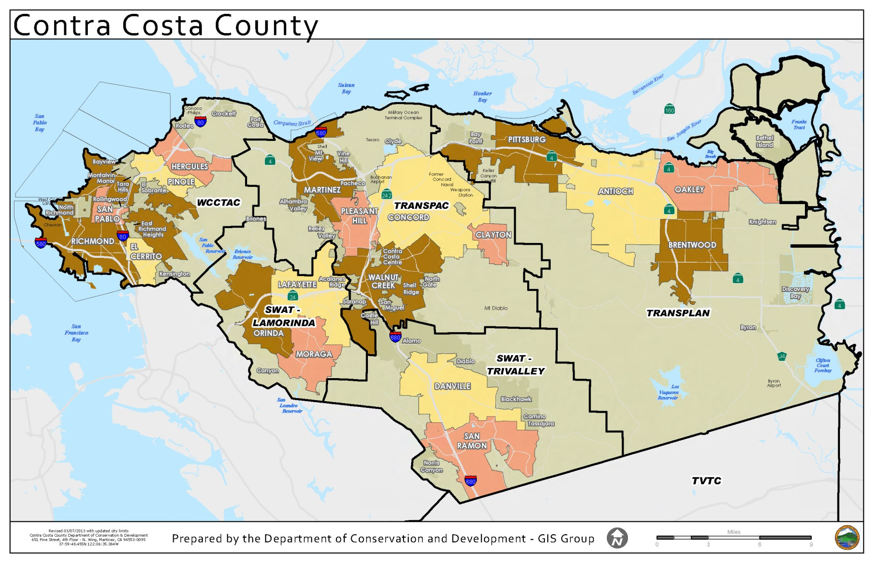

Equity Priority Community Maps

Source: https://opendata.mtc.ca.gov/maps/MTC::mtc-equity-priority-communities-in-2018-acs-2012-2016/explore?location=37.961568%2C-122.029225%2C12.24
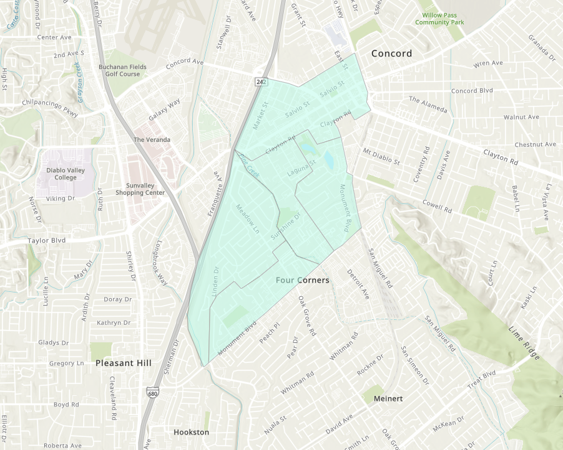
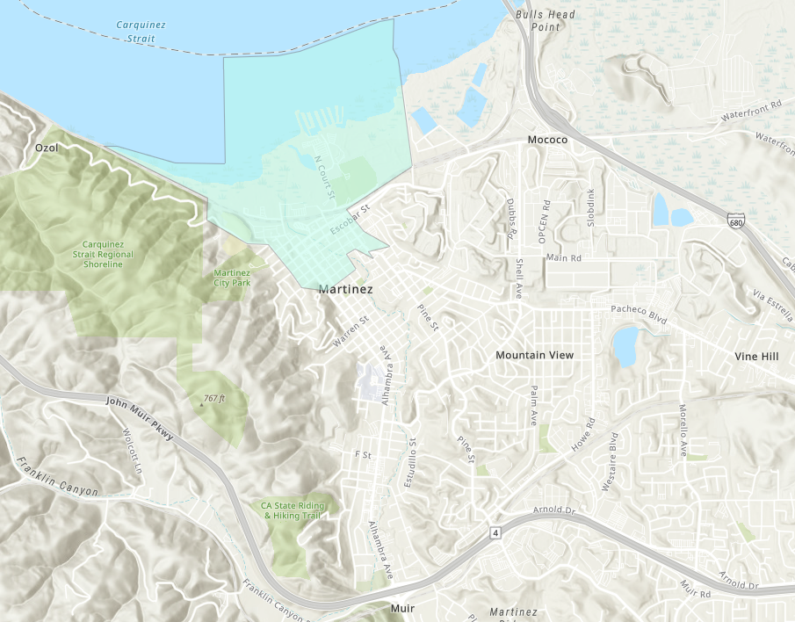

TRANSPAC Measure J Line 20a Funds
SAMPLE Progress Report for
July 1, 2024, to June 30, 2025
Period

Please provide the information requested in this Progress Report for your grant funded services / project.

Project Name | Sponsor | Funds Approved
Sample Project | Sample Organization | $XXX,XXX

Please complete the attached progress report form for the period of July 1, 2024, to June 30, 2025.
Progress reports should be emailed to:
Tiffany Gephart, TRANSPAC Clerk
tiffany@graybowenscott.com

Please submit the Progress report for the period from July 1, 2024 to June 30, 2025
by [Date].

Name of Agency:
Line 20a Grant Funded
Project Name:
Amount of Grant:
Supplemental
Progress Report Period: 7/1/24 – 6/30/25

Primary Project Contact
Name:
Phone:
Email:

Contact Information for who completed this progress report (if different from above)
Name:
Phone:
Email:

Reporting Data
- Summary of activities/services/impact made possible by grant funds (Please also include a summary of any variances of activities/services/impacts that resulted from the impact of COVID-19 if applicable).

- Line 20a Grant funded program number of unique individuals served - Input number of individuals served in the attached spreadsheet (see instructions at the end of the document). Please answer narrative questions below.

  - If the information requested is not available, please input N/A in the spreadsheet and explain here:
  - If applicable, provide information regarding variances in program offerings from initial application assumptions.

- Line 20a Grant funded program number of trips provided - Input trip information in the attached spreadsheet (see instructions at the end of the document). Please answer narrative questions below.

- If the information requested is not available, please input N/A in the spreadsheet and explain here:
- If applicable, provide information regarding variances in program offerings from initial application assumptions.

- Line 20a Grant funded program vehicle hours of service provided - Input vehicle hours in the attached spreadsheet (see instructions at the end of the document). Please answer narrative questions below.

- Please describe how a vehicle service hour is defined.
- If the information requested is not available, please input N/A in the spreadsheet and explain here:
- If applicable, provide information regarding variances in program offerings from initial application assumptions.

- Expenses - Input expenses in the attached spreadsheet (see instructions at the end of the document). Please answer narrative questions below.

- If the information requested is not available, please input N/A in the spreadsheet and explain here:
- If applicable, provide information regarding variances in program offerings from initial application assumptions.

- Line 20a Grant funded program vehicle service costs. Note: the cost per hour of service and cost per trip will be calculated automatically in the attached spreadsheet (see instructions at the end of this document for detail on how costs are calculated).). Please answer narrative questions below.

- If the information requested is not available, please input N/A in the spreadsheet and explain here:
- If applicable, provide information regarding variances in program offerings from initial application assumptions.

- Trip Characteristics. Input trip characteristics in the attached spreadsheet (see instructions at the end of the document). Please answer narrative questions below.

- Please list common destinations for trips within Central County.
- Please list common destinations for trips outside of the TRANSPAC area (if applicable). (See map at https://transpac.us/ for TRANSPAC area of Contra Costa County)
- Please list common trip destinations that cross transit service areas (i.e. that serve areas outside the County Connection service area).
- If the information requested is not available, please input N/A in the spreadsheet and explain here:
- If applicable, provide information regarding variances in program offerings from initial application assumptions.

8. Line 20a Grant funded program characteristics (at the end of the progress report period):
a. Please describe the current capacity of your program.
b. Please describe waitlist status and/or other program needs, barriers, etc.

9. First and Second Year Grantees - please attach drivers log or other substantiation of trips/routes. Subsequent year grantees must retain records for 3 years.

10. Please list any coordination activities with other transportation providers or mobility management functions (for example, sharing resources such as vehicles or facility space).

Instructions
Question 1: Overview
- Please provide a general description of your program and operations funded by the Measure J, Line 20a grant program. If there were no COVID-19 impacts in FY 2022-2023, please state so.

Question 2: Individuals Served
- Individuals Served (annual and monthly): Please only include unique individuals served by the funded project/program.
- All Individuals: if your program provided (10) people with a total of 100 trips over the reporting period, the program has (10) unique individuals served over the period.
- Individuals within TRANSPAC: If (2) of the people reside in Lafayette, (4) in Walnut Creek, and (4) in Concord, then there are (8) unique individuals in the TRANSPAC area. The TRANSPAC area of Contra Costa County includes Clayton, Concord, Martinez, Pleasant Hill, Walnut Creek, and the unincorporated areas within Central County (see map at https://transpac.us/).

Question 3: Trips
- Enter annual and monthly trips for each section.
- One-way passenger trips: If your program has provided 10 people a total of 40 round trips (or 80 one-way trips) and 20 one-way trips, a total of 100 one-way trips should be reported for the reporting period.
- One-way trips where origin AND destination are entirely within TRANSPAC: (see map at https://transpac.us/) regardless of the residence of the individual, these trips can be included.
- One-way trips where origin OR destination is within TRANSPAC: If the origin of the trip is outside of TRANSPAC but the end destination is within TRANSPAC or visa versa, those trips can be counted in this section.
- One-way trips with more than one passenger: Passenger A is picked up at a location 1, Passenger B is picked up at location 2, Passenger A and B are dropped of at location 3. This is an example of a shared vehicle trip.

Question 4: Vehicle Hours
- Vehicle hours monthly and annual ALL: Input the annual and monthly vehicle hours of service provided in FY 2022-2023 for all trips.
- Vehicle hours monthly and annual TRANSPAC: Input the annual and monthly vehicle hours of service provided in the TRANSPAC area of central county (see map at https://transpac.us/).
Question 5: Program Expenses
- Projected expenses should reflect what was reported in the initial grant application.
- Projected, Actual expenses as well as Line 20a funds expended should be for the period July 1, 2022 through June 30, 2023.
Question 6: Trip Costs
- Cost per hour of service: This will be calculated automatically (annual cost of the transportation program divided by the number of total vehicle hours of service provided).
- Cost per passenger trip: This will be calculated automatically (annual cost of the transportation program divided by the number of total one-way passenger trips provided).
- If there is a discrepancy between the excel calculations and your actual costs, please explain in question 6.
Question 7: Trip characteristics
- Total ADA Participants: Input how many program participants are certified to use ADA Paratransit services (i.e. County Connection LINK Paratransit).
- Total Participants from TRANSPAC area: How many ADA participants are from the TRANSPAC area?
- One-way trips for ADA Participants: How many one-way trips does your service provide for any/all ADA participants?
- One-way trips for ADA Participants (TRANSPAC Area): How many one-way trips does your service provide for ADA participants within the TRANSPAC area (see map at https://transpac.us/)?

Operations
- Days of Operation: e.g. Monday-Friday
- Hours of Operation: e.g. 24/7, 9am-5pm, etc. If hours vary by day please input that information, e.g. Monday -Friday 9-5, Saturday-Sunday 10-4.

Questions 8-10: Instructions for questions 8-10 are outlined in their respective sections.

First and second year nongovernmental grantees must have their Board of Directors authorize or approve the grant application by February 8, 2024. Authority for subsequent grant applications and reporting may be delegated to the agency executive officer.

